Reopening an airport in Ukraine: Leveraging Quantile Regression to Show Increasing Passenger Inflow May Enhance FDI Regardless of War

Author: Michelle Schultze

Date: Mar 12 2023

## Executive Summary

We found substantial evidence that the relationship between an increase in passengers flying into the country (on US carriers) and total FDI becomes more positive as the increase in passengers becomes larger, even when controlling for battle fatalities, GDP, and other metrics. **This supports the hypothesis that opening an airport in Ukraine, even though the nation is experiencing war, would likely result in an increase in FDI into the nation.**

## Data

We obtained monthly flight data from the United States to all international destinations, by US carriers for roughly the past three decades, from the [Bureau of Transportation Statistics](https://www.bts.gov/browse-statistical-products-and-data/bts-publications/data-bank-28im-t-100-and-t-100f-internationa-0). We also obtained macroeconomic data at the annual level, including foreign direct investment estimates, for the same time period, from [World Bank Development Indicators](https://databank.worldbank.org/source/world-development-indicators). We filled in some data from Ukraine in 2023 from International Monetary Fund estimates (IMF Country Report No. 23/399). Finally, to hone in on the impact of flight resumptions on FDI in conflict areas, we obtain [ACLED conflict data](https://acleddata.com/data-export-tool/), also at an annual level, for each country.

## Results

Total FDI was regressed on the **\*total\*** number of passengers flying into a country in that year (transformed by log+1 due to the magnitude of passengers), split into 10 deciles to investigate the effects at different X levels. This was the simplest regression we ran, and it was significant at all deciles except for the first (Table 1 and Figure 1, drawn from this [table](https://docs.google.com/spreadsheets/d/1zdZJibggs3bnYIdH_IBEw_Yauh2jkaMT/edit?usp=sharing&ouid=108231700962108858345&rtpof=true&sd=true) and [plot 5](https://drive.google.com/drive/folders/1aWE8uHWehkzHYkhUEF-UIRIQb_Y1fTOj?usp=drive_link)), showing that with the base relationship, the relationship between passengers flying into a country on US carriers and FDI in that country grows stronger as there are more passengers flying in.

Table 1: *Beta values (under ln_pass) and intercept values produced by regressing total FDI on natural log+1 of *total* passengers flying into a country from the previous year, split by deciles of the X variable.*

| tau | variable | coefficients |
| --- | --- | --- |
| 0.1 | Intercept | 31020000*** |
| 0.1 | ln_pass | -2184000 |
| 0.2 | Intercept | 93940000*** |
| 0.2 | ln_pass | 29790000*** |
| 0.3 | Intercept | 241600000*** |
| 0.3 | ln_pass | 71060000*** |
| 0.4 | Intercept | 357500000*** |
| 0.4 | ln_pass | 179800000*** |
| 0.5 | Intercept | 477600000*** |
| 0.5 | ln_pass | 339500000*** |
| 0.6 | Intercept | 716900000*** |
| 0.6 | ln_pass | 615800000*** |
| 0.7 | Intercept | 1.111e+09*** |
| 0.7 | ln_pass | 1.185e+09*** |
| 0.8 | Intercept | 1.691e+09*** |
| 0.8 | ln_pass | 2.194e+09*** |
| 0.9 | Intercept | 3.324e+09*** |
| 0.9 | ln_pass | 4.452e+09*** |
| 1 | Intercept | 1.457e+11*** |
| 1 | ln_pass | 1.64E+10 |

*Figure 1: Plot of the beta values produced by regressing total FDI on natural log+1 of *total* passengers flying into a country from the previous year, split by deciles of the X variable.*

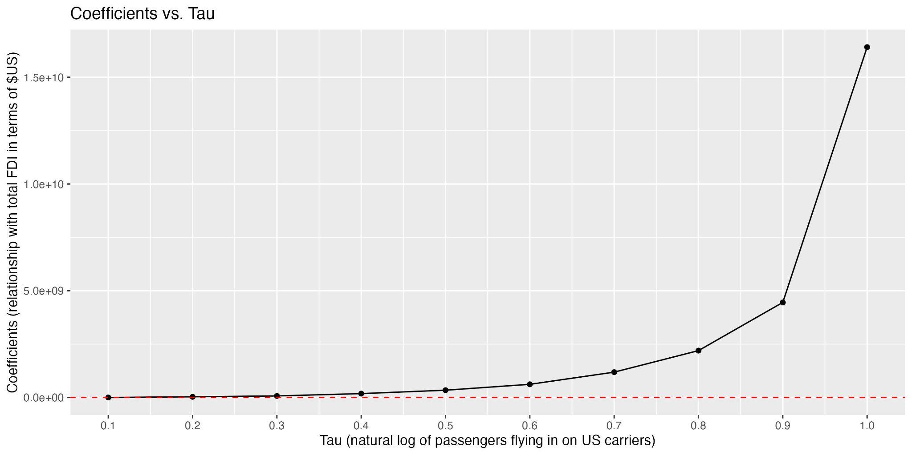

Total FDI (Y) was next regressed on \***percent change\*** in passengers flying into the country (X, transformed by log+1 due to the magnitude of many changes), again binned by decile to investigate the effects at different X levels. Taking the log does produce undefined values from negative values, therefore dropping big decreases in passengers flying into the country, but this effect essentially just narrows the interval of study of the X variable to just positive changes. This is acceptable because we are examining deciles, meaning that it is as if we simply are not examining what would be the lowest deciles of the X variable, simply “zooming in” our analysis to the higher deciles. Significant and positive changes were observed for the middle 20-90% of the X variable (Table 2, Figure 2), therefore **the relationship between an increase in passengers flying into the country and total FDI *becomes more positive* as the increase was larger.**

Table 2: *Beta values (under ln_passengers_pct) and intercept values produced by regressing total FDI on natural log+1 of percent change in passengers flying into a country from the previous year, split by deciles of the X variable.*

| tau | variable | coefficients |
| --- | --- | --- |
| 0.1 | Intercept | 36910000*** |
| 0.1 | ln_passengers_pct | -7617000 |
| 0.2 | Intercept | 142500000*** |
| 0.2 | ln_passengers_pct | 83980000 |
| 0.3 | Intercept | 307200000*** |
| 0.3 | ln_passengers_pct | 299900000*** |
| 0.4 | Intercept | 458500000*** |
| 0.4 | ln_passengers_pct | 507600000*** |
| 0.5 | Intercept | 815500000*** |
| 0.5 | ln_passengers_pct | 951800000*** |
| 0.6 | Intercept | 1.229e+09*** |
| 0.6 | ln_passengers_pct | 1.576e+09*** |
| 0.7 | Intercept | 1.843e+09*** |
| 0.7 | ln_passengers_pct | 3.503e+09*** |
| 0.8 | Intercept | 3.595e+09*** |
| 0.8 | ln_passengers_pct | 6.586e+09*** |
| 0.9 | Intercept | 1.758e+10*** |
| 0.9 | ln_passengers_pct | 1.435e+10*** |
| 1 | Intercept | 2.611e+11*** |
| 1 | ln_passengers_pct | 4.90E+10 |

*Figure 2: Plot of the beta values produced by regressing total FDI on natural log+1 of percent change in passengers flying into a country from the previous year, split by deciles of the X variable.*

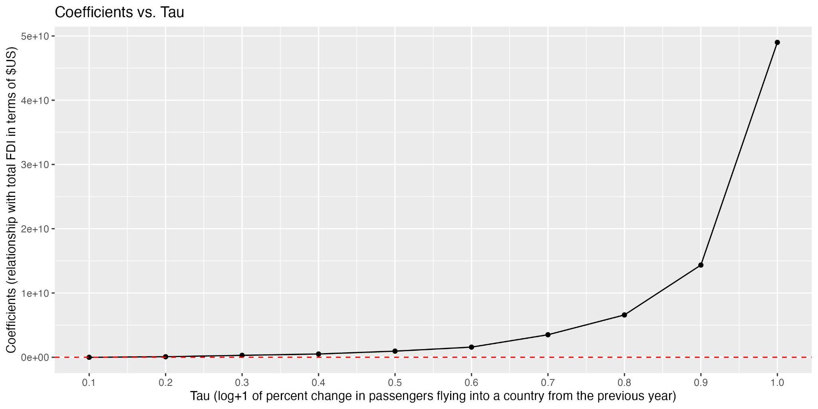

This relationship holds even when controlling for natural log of battle fatalities (drawn from ACLED data from that same year and country) (Table 3, Figure 3), though is again only significant for the middle 20-90% of the X1 (log of increase in passengers) variable.

Table 3: *Beta values (under ln_passengers_pct) and intercept values produced by regressing total FDI on natural log+1 of percent change in passengers flying into a country from the previous year, split by deciles of the X1 variable, controlled by the natural log+1 of battle fatalities. Beta values of ln_battle_fatalities can be found at the associated spreadsheet* [*here*](http://here)*. These coefficients are only significant for the middle 40-90% of X1 (log in percent change in passengers).*

| tau | variable | coefficients |
| --- | --- | --- |
| 0.1 | Intercept | 40870000*** |
| 0.1 | ln_passengers_pct | -7935000 |
| 0.2 | Intercept | 143200000*** |
| 0.2 | ln_passengers_pct | 83720000 |
| 0.3 | Intercept | 305200000*** |
| 0.3 | ln_passengers_pct | 299700000*** |
| 0.4 | Intercept | 472800000*** |
| 0.4 | ln_passengers_pct | 501500000*** |
| 0.5 | Intercept | 9.18e+08*** |
| 0.5 | ln_passengers_pct | 920500000*** |
| 0.6 | Intercept | 1.357e+09*** |
| 0.6 | ln_passengers_pct | 1.572e+09*** |
| 0.7 | Intercept | 2.059e+09*** |
| 0.7 | ln_passengers_pct | 3.51e+09*** |
| 0.8 | Intercept | 4.541e+09*** |
| 0.8 | ln_passengers_pct | 6.488e+09*** |
| 0.9 | Intercept | 2.114e+10*** |
| 0.9 | ln_passengers_pct | 1.512e+10*** |
| 1 | Intercept | 3.28E+11 |
| 1 | ln_passengers_pct | 3.14E+09 |

*Figure 3: Plot of the beta values produced by regressing total FDI on natural log+1 of percent change in passengers flying into a country from the previous year, split by deciles of the X variable, and controlled by the natural log+1 of battle fatalities.*

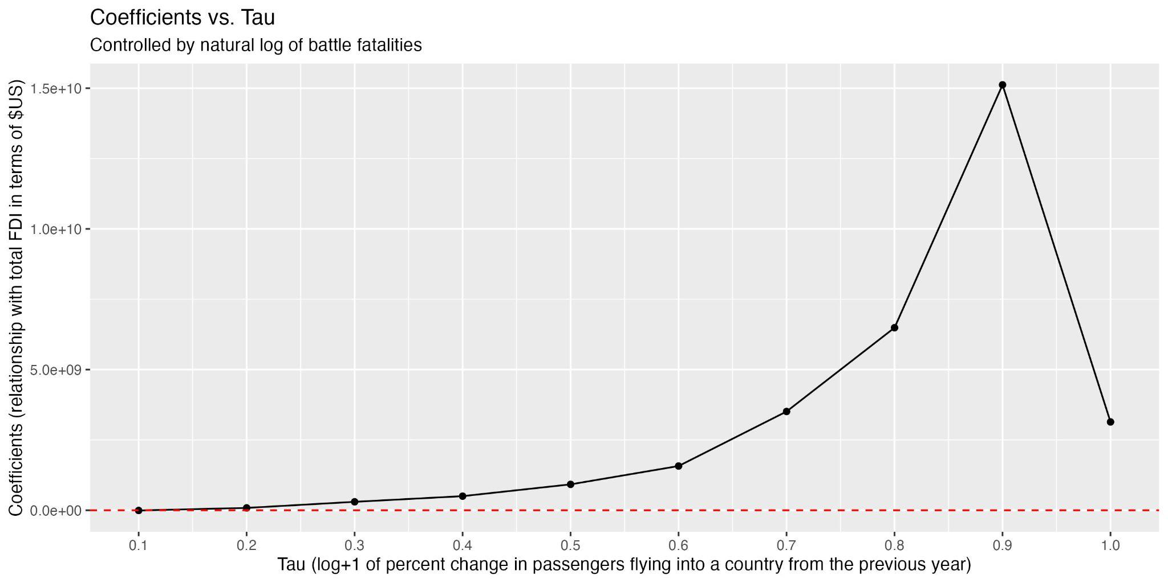

Lastly, the relationship holds even when controlling for GDP in terms of current (2022) $US, yet is only significant for the latter 40-100% deciles of the X1 (log of increase in passengers) variable (Table 4, Figure 4). Please note the spike in the beta at the end, which is significant for the passengers variable.

Table 4: *Beta values (under ln_passengers_pct) and intercept values produced by regressing total FDI on natural log+1 of percent change in passengers flying into a country from the previous year, split by deciles of the X1 variable, controlled by the natural log+1 of battle fatalities and total GDP in terms of current $US. Beta values of ln_battle_fatalities and the GDP variable can be found at the associated spreadsheet* [*here*](http://here)*.*

| tau | variable | coefficients |
| --- | --- | --- |
| 0.1 | Intercept | -113800000 |
| 0.1 | ln_passengers_pct | -231200000 |
| 0.2 | Intercept | -18840000 |
| 0.2 | ln_passengers_pct | -19250000 |
| 0.3 | Intercept | 36880000* |
| 0.3 | ln_passengers_pct | 18480000 |
| 0.4 | Intercept | 96630000* |
| 0.4 | ln_passengers_pct | 70090000 |
| 0.5 | Intercept | 167100000*** |
| 0.5 | ln_passengers_pct | 205700000*** |
| 0.6 | Intercept | 223100000** |
| 0.6 | ln_passengers_pct | 257200000*** |
| 0.7 | Intercept | 504500000*** |
| 0.7 | ln_passengers_pct | 269700000*** |
| 0.8 | Intercept | 9.67e+08*** |
| 0.8 | ln_passengers_pct | 366800000* |
| 0.9 | Intercept | 2.144e+09*** |
| 0.9 | ln_passengers_pct | 1.116e+09* |
| 1 | Intercept | 6.85e+10*** |
| 1 | ln_passengers_pct | 3.417e+10. |

*Figure 4: Plot of the beta values produced by regressing total FDI on natural log+1 of percent change in passengers flying into a country from the previous year, split by deciles of the X variable, and controlled by the natural log+1 of battle fatalities and total GDP in terms of $US.*

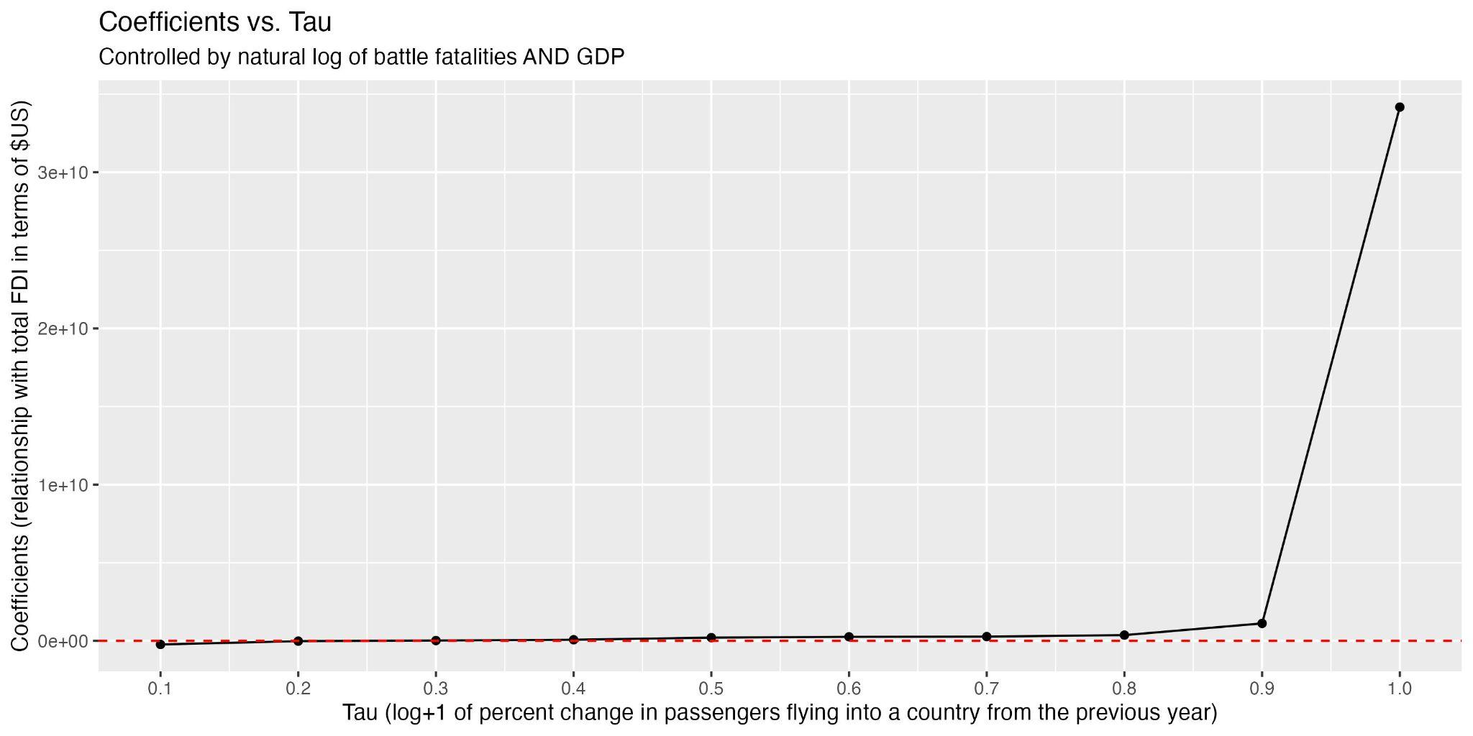

## Additional Robustness Checks

Several additional robustness checks were implemented on the first regression mentioned, the log+1 of *total* passengers variable. These included weighing the results based on log+1 of battle fatalities (and other fatalities variables). We also implemented a lead on the FDI variable (to regress NEXT year’s FDI numbers on THIS year’s log+1 of total passengers flying into the country), and controlling by a lag on battle fatalities (testing the relationship between THIS year’s FDI variable and THIS year’s total passengers flying into the country, when controlled by LAST year’s battle fatalities). Each of these regressions had significant coefficients between 20-90% of the X variable and followed the same positive shape (see this [table](https://docs.google.com/spreadsheets/d/1zdZJibggs3bnYIdH_IBEw_Yauh2jkaMT/edit?usp=sharing&ouid=108231700962108858345&rtpof=true&sd=true) and [plots 6-13](https://drive.google.com/drive/folders/1aWE8uHWehkzHYkhUEF-UIRIQb_Y1fTOj?usp=drive_link)). Controls were also included in the model to avoid endogeneity issues regarding battle fatalities and GDP, reaffirming the effects (see this [table](https://docs.google.com/spreadsheets/d/1nhn1rV_4HwozF8jfCxmkC7sDrtyFVeTm/edit?usp=sharing&ouid=108231700962108858345&rtpof=true&sd=true)).

The regressions using log+1 *percent change* in passengers were also replicated by implementing a lead on the FDI variable and a lag on battle fatalities (with the logic specified in the above paragraph). Both were significant and mirrored the other regressions (see this [table](https://docs.google.com/spreadsheets/d/1bRHO4N1yGBsNtLCLFuWsywLJBNL68pCC/edit?usp=sharing&ouid=108231700962108858345&rtpof=true&sd=true) and [plots 23-24](https://drive.google.com/drive/folders/1aWE8uHWehkzHYkhUEF-UIRIQb_Y1fTOj?usp=drive_link)). When implementing a robustness check by filtering the data for only years where the country experienced over 100 battle fatalities, the results were not very significant, but mirrored the other regressions in terms of shape ([plot 25](https://drive.google.com/drive/folders/1aWE8uHWehkzHYkhUEF-UIRIQb_Y1fTOj?usp=drive_link))

Note that we also tried using percent change in passengers flying into the country (without the log), as well as percent change in total FDI (rather than total amount of FDI), and found not very significant results (see this [table](https://docs.google.com/spreadsheets/d/1bRHO4N1yGBsNtLCLFuWsywLJBNL68pCC/edit?usp=sharing&ouid=108231700962108858345&rtpof=true&sd=true) and [plots 14-19; 26-31](https://drive.google.com/drive/folders/1aWE8uHWehkzHYkhUEF-UIRIQb_Y1fTOj?usp=drive_link)). Running the regressions with log+1 of the percent changes in **both** FDI and passengers flying into the country did not solve the problem, since taking the log+1 of the percent change in FDI produced many NAs, since several countries had negative net inflows of FDI into the nation, biasing the beta values.

*Please contact Michelle Schultze for any queries regarding this write-up (*[*mks84@duke.edu*](mailto:mks84@duke.edu)*).*